Prototype Acceptance Plan Trav’Help

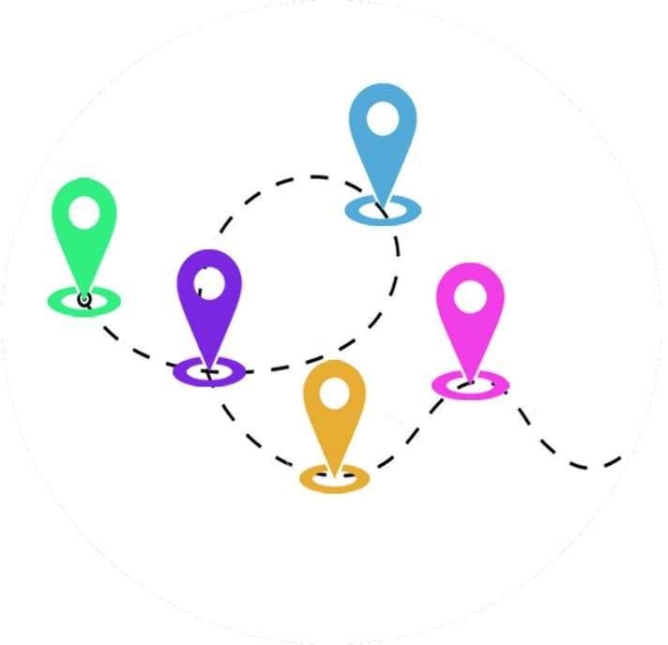

I4-PAP-1970-20191107

12th of december, 2019

**Rappels** : Dans le cadre du programme de **V**alorisation des **P**rojets des **E**tudiants « VPE », il est proposé aux étudiants de l’ECE la mise en place **de projets innovants à visée industrielle ou de recherche** pour leur **permettre de se différencier**.

Ce programme est basé **sur une pédagogie inductive**. Il tend à couvrir l'ensemble des étapes d'élaboration d'un projet innovant, **de l'idée à sa mise en œuvre.** Ce dispositif est mis en place et développé de la 4ème à la 5ème année.

Ce programme se déroule selon les étapes suivantes

Une **phase initiation,** les étudiants reçoivent les bases pédagogiques pour appréhender la mise en œuvre de projets innovants

Une phase **architecture projet,** les étudiants, en équipe, développent le contexte, l’objectif et les idées innovantes du projet sous forme d’arborescence, compilant les différents aspects du projet pour construire une vision globale réfléchie et pragmatique. Les étudiants définissent par eux-mêmes la pertinence du projet.

Une phase **(preuve de concept)**, les porteurs de projet rédigent les protocoles et réalisent les manipulations technologiques pour apporter la preuve technique du projet.

Une phase preuve de concept consolidée **(preuve de concept préindustrielle)**, impliquant des notions de : de marketing (SWOT), propriété intellectuelle, de réglementation, d’analyse de la concurrence, d’analyse du cycle de vie ( ACV )de la solutions ainsi que le bénéfice /cout environnemental & sociétal .

**Ce modèle de RAPPORT ne comprend pas les éventuels jalons demandés par l'entreprise partenaire ni l'axe de valorisation choisi, qui doivent être formellement définis dans le cahier des charges préparé par l'équipe**

# Revision history

|  |  |  |
| --- | --- | --- |
| Name | Date | Changes |
| 1rst version | 07/11/2019 | Creation of the document (p.1-p.6) |
| 2nd version | 08/11/2019 | Project desriptions + Tasks Distributing |
| 3rd version | 12/12/2019 | Technical feasability |
| 4th version | 01/04/2020 | Final version |
|  |  |  |

# Table of Contents

*The table of contents should preferably fit on a single page for readability and navigability. Playing with the TOC styles can help get it to fit. (This may not however be possible)*

Table des matières

Revision history 2

Table of Contents 3

1 Introduction 4

2 Documentation and terminology 5

2.1 Reference documents 5

2.2 Glossary 5

3 Project Description 6

3.1 Origin of the Project 6

3.2 Product/solution description 6

3.3 Innovative nature of the technology/ solution 6

3.4 Freedom of exploitation, risk of counterfeiting 6

3.5 Regulatory aspect 6

3.6 Market study and value creation 6

3.7 Market positioning and competitive advantages/ Environmental cost/ benefit 6

3.8 Work program and expenditure 7

3.9 Technical milestone 7

3.10 Market milestone 8

3.11 Legal security 8

3.12 iWhat are you going to do with the product/solution at the end of the project?/ What is the lifetime p roduct/solution? 8

4 Function and contribution of the actors 9

5 Research part 11

6 Test suite 12

6.1 Fitting every parties’ imperatives 12

6.2 Requirement 2 12

7 Conclusions & Perspectives 13

Appendix A. Additional appendices as necessary 13

# Introduction

A liberal nurse has a daily morning routine of visiting 25 to 30 patients a day at their place. This accounts for about a thousand kilometers they must drive weekly, for the sole purpose of getting to their patients’ home. The driving part represents a good third of their time.

We then asked ourselves : is there any way to give time to liberals, for them to do what is meaningful ? This is with that in mind that we designed Trav’Help, and that we started looking for a way to optimize liberals’ schedules.

This optimization problem is related to the Traveling Salesman Problem, which is a famous NP-complete one* that has been sought by many people for a long time. However, it has a less known variant : the Traveling Salesman Problem with Time Windows. This problem is about finding the shortest possible route that visits each dot, while respecting some time constraints for each dot. This problem fits exactly our optimization problem for liberals’ schedule, where every dot – in our case, patient – has to be visited when available.

There are already some implementations of solutions to this problem. However, as we need to find the travel time between two patients, we must use an API. The implementations we found did not quite match our expectations. Indeed, they would call all needed distances, regardless of whether they are needed or not. It gets expensive to call those APIs that much. Furthermore, we used different parameters than them.

Because of that, we decided to implement one solution ourselves. Its explication is further up in the document.

This project aims at tackling different societal aspects. First comes the social one : liberals would stop spending their time in driving, rather than in their actual job: meaning services of higher quality. It also has an economic aspect, where liberals become more time efficient as they drive less, thus consume less. Finally, reducing liberals’ car consumption also helps in decreasing greenhouse gases emissions, as well as noise pollution.

This document will give complete information about our project, Trav’Help, and its modifications. We will regularly recap our different missions and put a glossary with reference sections so it will be easier to understand our project.

Happy reading.

*\*refer to the glossary*

# Documentation and terminology

## Reference documents

|  |  |  |  |
| --- | --- | --- | --- |
| **Document** | **Number** | **Attached?** | **Application** |
| Document name | Code, number, version | Yes/No | The role of the document relative to the CDC |

## Glossary

* + 1. **Terms**

|  |  |
| --- | --- |
| NP-complete problem | A problem is said to be NP-complete when it is easy to find if a solution is the best, yet really difficult to find this solution. |
| Clustering | Clustering is grouping a set of objects in a way that objects in the same group (called a cluster) are more like each other than to those in other groups. |

* + 1. **Acronyms**

*Define the meaning of all acronyms and abbreviations used in the CDC. When the literal meaning of the acronym or abbreviation is not sufficiently clear or precise, provide an additional explanatory text.*

|  |  |  |
| --- | --- | --- |
| **Acronym** | **Meaning** | **Explanation** |
| TSPTW | Traveling Salesman Problem with Time Windows |  |
|  |  |  |
|  |  |  |

# Project Description

## Origin of the Project

We have met several nurses in liberal profession. They want to reduce the time spent in driving. We want to optimize their schedule to see each of their patients with different addresses in a minimum of time.

## Product/solution description

The solution to this problem is a mobile application which takes every address, as well as each patients’ availability, to find the best route which visits every address once and go back to the nurse's home in the shortest time.

## Innovative nature of the technology/ solution

The innovative nature of the project lies in the implementation of the TSPTW problem. This part is defined further up in the document.

## Freedom of exploitation, risk of counterfeiting

We are free to exploit this idea, as it is new.

Risks of counterfeiting are low because our idea is original, and not spread. We have not published our researches yet.

## Regulatory aspect

There is not any issue, political or ethical, in France or internationally, that would be an obstacle to our project.

It does not involve any tendentious topic; idea is new and has no other impact than reducing liberals’ amount of driving.

## Market study and value creation

Our research has shown that there is no existing patent on the exact same topic, and no custom solution to liberals was designed yet.

Some patents already exist on a somehow related issue, but they propose a wholly different solution than ours.

## Market positioning and competitive advantages/ Environmental cost/ benefit

It would help to reduce pollution by keeping liberals from using unnecessary transportation.

They would have more time for their work, which means higher quality of cure, and better relations with the patients themselves.

## Work program and expenditure

Expenditure-wise, we have not spent any money yet during the test period.

We have a partnership with Google. They lent us 300€ worth of API calls for a year. This amount is more than enough for the testing part.

If we were to commercialize the application further, however, we would need an actual contract with Google API for our application to work. We need the distances and times they provide us for our application to work.

## Technical milestone

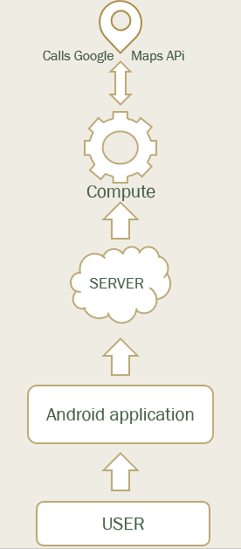

First, the user interacts with the application thanks to the thanks to the UI. Then, the user can add some contacts in the application the name of the patient, their phone numbers and most of all the addresses. Then, the user can decide to save their data in the server or in their phone directly.

In addition, the implementation of the code can allow the user to load her perfect schedule, and the perfect path to gain a maximum of time during her journey. Thanks to the API calls made by the server, the user can finally watch the itinerary, client by client optimize thanks to the code with the respect of the desire and the free time of the client. With this application, the user will be able at the end to save the contact, plan her schedule and view the itinerary.

## Market milestone

After having conducted the project to its end, we shall look for partners in the liberals’ world by introducing them our application, and possible common benefits both parts could take out of this project.

According to their answer, we will rethink the way we designed the project.

If they think the project is worth sharing, we may make it available to public, most probably thanks to the Google Play Store platform.

## Legal security

For the moment, we have not registered our algorithm in a Soleau envelope, nor have patented it.

However, given we have not published our results yet, we do not see any legal security issue in the near future.

If the project is to grow bigger, we will rethink our position towards this point.

## iWhat are you going to do with the product/solution at the end of the project?/ What is the lifetime p roduct/solution?

It has a double goal.

First, on a practical aspect : it depends on liberals’ contacts we may have. If they consider our project worth sharing, we definitely will consider doing it. If they fail to see how our project may help them, we will probably put the project to its end.

Secondly, this project has a research aspect. Indeed, the research we have done is new and might be useful. This is here to stay.

Regarding PFE : we do *not* consider pursuing this project into a PFE one. It is not about the project in itself, rather that 5 of our 6 members will go for an exchange semester into another country.

# Function and contribution of the actors

Karla FLATRES

Background :Finance (SE)

Function and contribution :

* Take care of the research and documentation part
* Design of both posters
* Write deliverables

Motivation and personal commitments :Curious about the Salesman Problem, I was wondering how we could approach the problem. The fact that we studied clustering in finance made me think that it could be possible to solve our problem.

Marc-Antoine HERVÉ

Background :Finance

Function and contribution :

* Theory and implementation of the algorithm
* Finalize algorithm, tests and research part

Motivation and personal commitments :initially interested in programming and machine learning, really thrilled about the ideal of looking for an old math problem and willing this Project the further it can get

Pierre LELIÈVRE

Background :Information Systems (SI)

Function and contribution :

* Project manager
* Finalize algorithm and research parts
* Code the server part
* Code the mobile application part
* Write deliverables

Motivation and personal commitments :Initially, the idea came from the will to enhance liberal profession's working routine, as Pierre has some family directly involved in this field. Furthermore, he enjoys his team manager position and wishes this project will result into a great experience.

Robinson MATHIEU

Background : Information Systems (SI)

Function and contribution :

* Theory and implementation of the algorithm
* Code the mobile application part
* Write deliverables

Motivation and personal commitments :interested in the Salesman’s problem and about all the mathematical formulas and knowledge that we can use to resolve this problem. It remembers him the period of his preparatory class.

Quentin ROCHA PINTO

Background :Embedded System (SE)

Function and contribution :

* Theory and implementation of the algorithm
* Code the mobile application part
* Write deliverables
* Work on tests and research parts

Motivation and personal commitments :His main motivation in this project comes from the research aspect. Working on this problem of optimization is very interesting and motivating because it is a concrete problem that can affect all of us. This "Salesman Problem" makes it possible to reach many interesting areas such as algorithmic mathematics and the use of new languages.

Diego SANCHEZ

Background : Energy and Environment (EE); International student from Mexico. Joined the group in February 2020.

Function and contribution :

* Code the server part
* Make the video
* Write deliverables

Motivation and personal commitments :His motivation is to be able to have more knowledge about how to develop an app, in addition to being able to generate value for society with the project we are working on.

# Research part

## Context

## Problematic

## State of art

*An Exact Algorithm for the Time Constrained TSP* by Edward K. Baker (1983)

This research paper was the first one introducing the Time Constrained Travelling Salesman Problem (TC-TSP) using the same kind of model we are using in our research which is a different number of cities (patients house for us) that have to all be visited with the shortest distance possible while taking care of the upper and lower bound of the city which represent the time interval where they have to be visited.

However, it is using a different way of solving the problem which is a bit too simple. In the first place it is using an algorithm to find the distance between all cities with the help of the triangle inequality and referring to the Hamiltonian path. Which lead to the shortest path possible without considering the time constraint of each cities in a first way. Moreover, in this algorithm the next city in the sequence will always be the one that is the closest to the actual city.

This is already different than our algorithm idea because we are using considering the time windows of every “city” at the very beginning of our algorithm and we are not looking for the shortest distance between the two cities at every node but we take all the possibilities and process them with our criteria to get rid of the ones that are irrelevant.

Then, on the second place, the algorithm from Baker’s research receive a shortest distance sequence and will now have to process it by taking the time windows in count. The way it is dealing with those constraint is the following, if a node/city can be visited and is the next one in the sequence, it will be, if not, the traveler will have to wait at the city for the lower bound of the interval to be reached and if a cities upper bound has been outdated then the algorithm will not find a solution.

Our algorithm works in a different way here because at each sequence and at the end of the algorithm we will be reducing the waiting time at the maximum by not taking in count the cities where the lower bound have not been reached and will get rid of the sequences where the upper bound of a city is outdated is the city is not in the sequence yet.

*An Optimal Algorithm for the TSP* by Yvan Dumas, Jacques Desrosiers, Eric Gelinas, Marius M. Solomon (1995)

This paper presents the development of new elimination tests which greatly enhance the performance of a relatively well-established dynamic programming approach and its application to the minimization of the total traveling cost for the traveling salesman problem with time windows. The tests take advantage of the time window constraints to significantly reduce the state space and the number of state transitions. These reductions are performed both a priori and during the execution of the algorithm.

The branch-and-bounds solution given by researches like Baker’s where effective but only for a small number of nodes (50 max) and with very reduce width, this is why other searchers were looking for a more optimal solution of the TC-TSP that could work with larger bounds and with a greater number of nodes at the same time.

The largest difference with our algorithm is the use of a dynamic method that will not provide the most optimal solution for sure and the fact that they are calling all distances at the beginning of the computing process whereas our algorithm provides the exact solution by construction and only calls the distances if there is no other way to compare sequences with each other to find the exact one.

However, this algorithm can compute up to 200 nodes and more than a 100 with a large width of bounds.

Dynamic Programming Strategies for the TSP with Time Window and Precedence Constraints by Aristide Mingozzi, Lucio Bianco, Salvatore Ricciardelli (1997)

In this paper, the searchers were looking for an exact way of solving the problem using a solution that is similar from Mr Dumas solution which means by using dynamic programming in order to solve the problem efficiently. Indeed the Dumas’ solution lack some condition to be more effective and some of those solution are related with our criteria to get rid of some sequences that are not optimal : for example the fact that is a node as not been visited yet but the upper bound is outdated we get rid of the sequence.

However, this is still dynamic programming, so it has a major difference with our algorithm even if it improves the dynamic solution of Mr Dumas.

*A compressed-annealing heuristic for the TSP with time windows* by Jeffrey W Ohlmann, Barrett W Thomas (2007)

This paper describes a variant of simulated annealing incorporating a variable penalty method to solve the traveling-salesman problem with time windows (TSPTW). Augmenting temperature from traditional simulated annealing with the concept of pressure (analogous to the value of the penalty multiplier), compressed annealing relaxes the time-window constraints by integrating a penalty method within a stochastic search procedure. Computational results validate the value of a variable-penalty method versus a static-penalty approach. Compressed annealing compares favorably with benchmark results in the literature, obtaining best known results for numerous instances. This paper shows how more recent researches about the TSPTW has evolved, with the use of stochastic methods and the use of penalty with the annealing method. This is now of majority of searchers are working to solve the TSPTW but once more, this algorithm will be using the Monte-Carlo method also used in the world of finance to predict stock variation. However, because it uses Monte-Carlo which is a stochastic approach it can solve a greater number of nodes but it is not an exact solution (fluctuate with the variation of the k parameter which is the cap ratio). We clearly see here the different path that the research is taking with this stochastic method and our try with an exact but more “old school” method.

## Methodology

We consider patient to have the following characteristics : [lower bound, upper bound, address]

Let us consider the following problem :

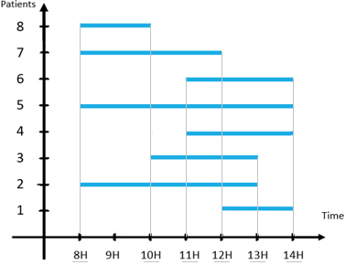

Construction of all time-intervals we are going to work on

Each with time interval has a lower bound and an upper bound.

Process to sort the array [minA, maxA, minB, maxB, ...] where minA is the lower bound of patient A (the earlier you can visit the patients considering his time constraint) and maxA upper bound of patient A (the end of the patient time constraint)

It leads to this kind of construction:



Where each interval will be a loop of the program during computation, first one with [8,10] then [10,11], etc.

Loop over the different time-intervals

Between each interval of the sorted array, we:

Consider available patients for the time period

For each of those patients, we try building sequences using them.

In our example, patients available in the first time-interval are : [2, 5, 7, 8]

But for simplicity, let’s consider there are only three patients, 1, 2 and 3.

We try out every possibility/combination of sequence (including those that do not take all patients available in it).

In our case, we get :



(with 4 patients, we would have had 65 different sequences).

In some sequences, some patients are missing. That is because, they are still available in the next time interval : meaning, they could be visited afterwards. We have to consider this case in order to do all the cases.

For simplicity again, let us consider that patients 2 and 3 *have* to be cured in this first time interval. We then have to remove every sequence that is not built out of patient 2 and 3.

The remaining sequences are :



We just finished the first iteration of the loop. Let’s move onto the second passage in the loop.

Second loop

Let’s consider there is another patient, 4, that *has* to be visited during this second time interval, as well as patient 1.

We are going to build all new sequences, taking this information into account, using the same process as last time.

However, this time, the new sequences will be built from the one we had last time ; we simply add all possible new sequences, to the one already existing.



In this case, we notice that some sequences are necessarily redundant, and we are sure that we will not choose this sequence to be the final one.

Identifying similar sequences

Indeed, sequences [3, 2, 1, 4] and [3, 1, 2, 4] are *similar*.

We consider two sequences as similar if they :

* start with the same patient;
* finish with the same patient;
* visit the same patients.

We now have to find which sequence to remove.

Computing time needed for a sequence

We will then compute the time needed for each sequence, in order to know which one is to be removed.

Let’s compute traveling time needed for sequence [1, 2, 3, 4] :

T = T(1,2) + T(2,3) + T(3,4)

where T(*x*,*y*) represents the time from *x* to *y*.

If a T(*x*,*y*) has already been computed no need to compute it again, it will be kept in the distance matrix.

We need the useful distances that will be kept in a distance matrix. Some distance will never be used, thus never called.

For instance, in our example, we never need to know T(4,2), nor T(4,3).

Removing similar sequences thanks to the distance

Then, we will go through the list of sequences to look for those that can be suppressed. Arbitrarily, and for simplicity, we will choose those distances for each sequence, and remove sequences that are removable.



Removing impossible sequences

We also delete the strings that does not respect the patients bounds.

Let’s consider a sequence of patients [1, 2, 3, 4] on the time interval [10, 11]. Let’s also consider patient 5, that had to be visited between [8, 10].

The sequence above will be deleted because it is too late to visit patient 5 (works in the same way if it is too early)

At the end of the loop

When all of this is done for every time interval, we should have only one sequence remaining : the final solution.

As we construct, by recurrence, all our sequences without omitting any, we are certain the final solution is the only one that fits the schedule, and that is the faster.

## Prototype

### Environment of development

We implemented the solution above using Python.

### Implementation of each function

Every function’s implementation is pretty basic, and uses no complex implementation, other than following the above algorithm. Source code is available in Appendix A.

### Special mention to the “remove similar sequence” function

Indeed, this function accounts for roughly 95% of our program execution time.

Depending on how full the sequence list is, the function takes a really long while to finish.   
  
Its implementation is about going through the list with two indexes *i* and *j,* and comparing if sequence[ i ] is similar to sequence[ j ]. The complexity of this function is O(n²), which is why it takes a really large amount of time to finish.

### How to use it

To use it, you only have to run the code.

As exposed before, the profile of the journey will greatly impact performances, as well as time needed.

That is why we implemented to ways to create the journey.

First way : manually



Those lines here are used to choose manually the journey’s characteristics.

The blue part represents the distance/time between each point. For instance, if you take the number with coordinates [4,3], it represents the time needed to go from patient 4 to patient 3. Please note that the distance/time to go from A to B is not necessarily the same as the distance to go from B to A, depending on how the routes are done.

The green part represents the time window in which a patient is available. It means, for instance for patient 1, that they are available from the start until 20 time units.

Using this, we can test custom journeys.

Second way : randomly

We fill up the same table as above, unless this time it is done randomly, following a certain pattern.

We start by randomly picking a value within working hours. This will be the middle of our interval. Then, we create the width of the interval, using a standard width, to which we add up some variance.

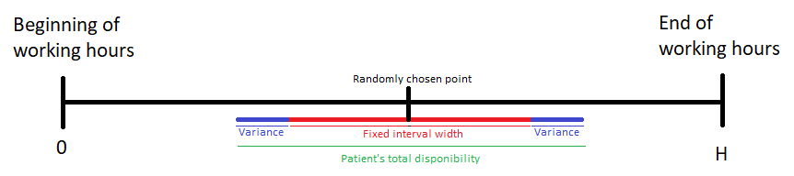

We repeat this process to fill up the journey with each patient’s availability.

Eventually, we get a result that looks like this :

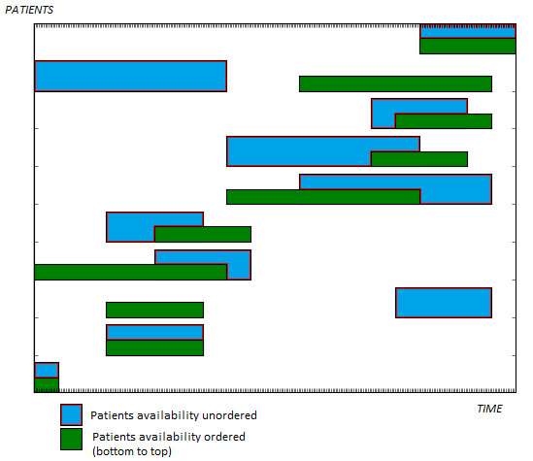

## Tests

## Conclusion and Perspectives

We

## Bibliographic References

# Test suite

## Fitting every parties’ imperatives

The schedule computed should fit in the professional's imperatives, as well as each person they visit's, meaning that no meeting will be taken out of the time bounds previously set.

If we apply this to the liberal professions, we could expect the schedule to respect the time they were assigned to.



|  |  |  |  |  |
| --- | --- | --- | --- | --- |
| ***No. Description*** | | ***Execution scenario*** | ***Expected results*** | ***OK/NOK*** |
| ***1*** | *Schedule must fit in both parties' imperatives.* | *Trying our algorithm on a data set where we know there is a solution that fit both parties' imperatives.* | *Finding a solution that fits in both parties' imperatives.* |  |
| ***2*** | *Schedule doesn't fit in at least one party's imperative.* | *Trying our algorithm on a data set where we know there is NO solution that fit both parties' imperatives.* | *Not finding a solution that fits in both parties' imperatives.* |  |

## Requirement 2

Among a set of solutions that are known to fit in both parties' imperatives, find the fastest one. If one can start later and finish earlier, this solution should be preferred to another one.



|  |  |  |  |  |
| --- | --- | --- | --- | --- |
| ***No.*** | ***Description*** | ***Execution scenario*** | ***Expected results*** | ***OK/NOK*** |
| ***3*** | *Schedule given is the most optimized one* | *Using sets of data in which we know the most efficient scenario.* | *The schedule found is the most effective one.* |  |

# Conclusions & Perspectives

In this document, we described precisely our project (the main problem and the final goal)

and what we need to design it. W e have seen the different documents needed to understand

a nd start in a good way the project. We also described all the actors of this project and their contributions, motivations to the project. Each member has something to add to the project and thanks to all the environment that we are going to implement for the testing phase, we should be able to make and test this algorithm. This algorithm will be the result of the coordination of the team, the researches on the subject, the searches on the code and its optimization but also the guidelines of our mentor.

# Appendix A. Python Source Code

# <https://github.com/Azorlebleu/ECE_PPE>